**Adina Pervaiz**

Software Engineer | .Net Full Stack Developer



Karachi, Pakistan pervaizadina@gmail.com



+92-306-8119606

Compassionate, analytical and effective IT expert with valuable experience in different computer and software skills & languages. Has variety of skills and knowledge of different computer, software and programming skills, languages, experience working as a software engineer with international organizations. Having strong experience in Backend (C, C++, C#, Java and Python) and Frontend (HTML, CSS3, Java scripting, Angular and PHP) languages as well as Database Management system (MySQL)



**Work History**

**2022-CurrentDate Software Programmer**

Tracking World

* Writing clean code for the front and back end of the software
* Creating Test Cases
* Creating stored procedures in MySQL databases for the back end of the software
* Connecting API’s with database and then with the frontend program and test accordingly.
* Developing and Testing APIs

**2020-2021 Associate Software Programmer for Dubai, UAE**

Techport Solutions

* Helping with the design and development of software
* Testing and debugging software to keep it optimized
* Writing clean code for the front and back end of the software
* Designing user interactions on the web application itself
* Creating stored procedures in MySQL databases for the back end of the software
* Connecting API’s with database and then with the frontend program and test accordingly.
* Ensuring cross-platform compatibility and optimization
* Testing and maintaining the responsive design of applications
* Working with graphic designers to design new features
* Developing APIs and RESTful services
* Keeping up with technological advances to optimize their software
* Communicating effectiveness of emerging technologies to decision makers
* Considering security, maintenance, scalability, and more when developing

**2017-2020 Ilm-un-nisa Welfare Organization**

Computer Skills Trainer

* My major task was to accomplish goals by working as a team with an institute’s administrator and chairperson.
* Train students about basic computer knowledge and give basic guidelines on computer programming.

**2013-2016 Academic Writer**

Writers Club

* I started writing thesis, essays and paraphrasing tasks for students. My task was to write three thousand words per day on all business related subjects.

**2009-2011 Customer Services Representative**

Arwen Tech

* I was working for Adamjee Insurance that has outsourced its business to Arwen Tech.
* My responsibilities were to take different medical and vehicle claims over the phone and resolving client matters by sending a request to the company to arrange a surveyor.
* For medical claims, I was responsible to connect the patient to any of the panel doctor and guide the client accordingly.

**2007 – 2009 Customer Services Representative**

PTCL (Pakistan Telecommunication; partner of Etisalaat)

* Handling and resolving customer complaints/ queries over phone and providing customers with relevant product and service information.
* Cross selling various telecommunication products to customers over phone.

**2006 – 2007 Phone Banking Officer**

Standard Chartered Bank

* Handling and resolving customer complaints/ queries over phone and providing customers with relevant product and service information.
* Cross selling various banking products to customers over phone.
* Perform all banking tasks on phone that can be done from branch banking through walk-in.

**2005-2006 Telesales Officer**

Union Bank

* Providing information to customers related to the selling product i.e. American Express Card.
* Updating customers’ records, keeping a track record of calls and relevant details.



**Education**

2022 **Masters in IT**

Virtual University of Pakistan

2009 **Master’s in Business Administration - Marketing**

PIMSAT, Karachi Pakistan

2005 **Bachelors in Commerce**

Government College of Commerce and Economics, PIDC, Karachi Pakistan

2003 **Diploma in Software Management - DISM**

Aptech, Sharah-e-Faisal, Karachi Pakistan

2002 **Intermediate in Pre-Engineering**

Government College of Women, Shahrah-e-Liaquat, Karachi, Pakistan

1999 **Matriculate in Science**

Zeal Public School, DHA phase-2 ext, Karachi, Pakistan



**Skills, Certificates & Projects**

**Technical Skills**

* C, C++, Java and C#
* HTML, CSS, Java script (JQuery & Bootstrap) and Angular
* MySQL

**Other Skills**

* Software Development
* Web Development and basic Designing
* Program creation and execution
* Deployment
* Client servicing

**Certificates**

Awarded certificates in the following programs:

* Certificate of Participation in Developer Student Clubs 2020 DSC-VU Hackathon
* Digital and Cyber Security 2020
* Visual Data Analysis Using R Software (Department of Statistics, Virtual University of Pakistan)
* Fiber Optics Infrastructure Designing by Mr. Imran Khan, Head of Trainer (UCP Pakistan)
* Change Management conducted by Mr. Kashif Hashmi, Director Marketing (CAA)
* Careers in Media conducted by Mr. Shahbaz Siddiqui, CEO/Executive Producer (Nucleus Media)
* Creativity in Advertising by Mr. Mohammad Asher Khan, Marketing Executive (Nova Medicines)
* Future Prospects Abroad by Ashfaq Suleman Khanani, CEO (Ask Consultants)
* Seven Habits of Highly Effective People by Mr. Kamran Ahmed (Faculty Member PIMSAT)

**Projects**

* Created and deployed CRUD pages on <https://www.techportsolutions.com/ekontenerp>
* Created one, two and three page master pages with CRUD operations and performing unit test on each and every task assigned.
* Created related stored procedures associated with each CRUD pages.
* Created and deployed Signin button with Microsoft Azure.
* 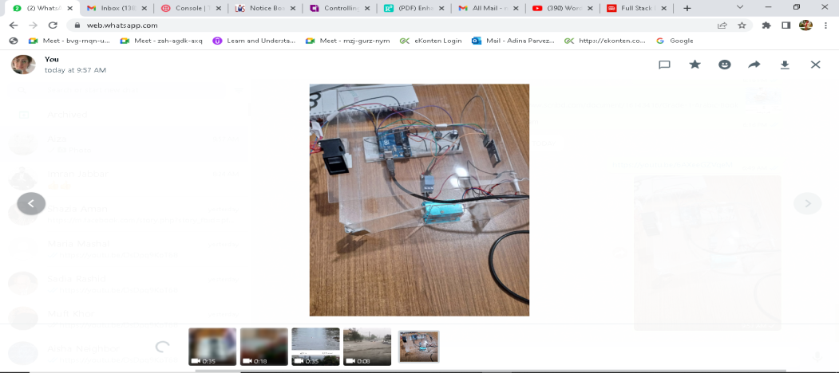Developed a smart door IoT based lock system